Experiment 02

**BLINKING OF LED USING 8051 MICROCONTROLLER USING KEIL AND PROTEUS**

**AIM:**

To Write an assembly language program to LED blink using 8051

**SOFTWARES REQUIRED:**

* Keil software

**KEIL PROCEDURE:**

1. Open the software, Click on project and open new version project.

2. Create a new project file

3. Enter AT89C51

4. Click NO

5. Click [Ctrl +N] and Type the code

6. Open project and click Build target

7. Open Build target and open source file and ADD, CLOSE

8. Click build target

9. Next debug start and stop

10. Open peripherals and select port 2

11. Now run the program in Debug

12. Open project and click optional properties and in that give output as hex file.

13. Create hex file.

**PROTEUS PROCEDURE:**

* Open proteus by clicking run as administrator.
* Open new project and enter the file name.
* Click next, next, next and finish.
* Click P symbol and search keyword and place the required components

The components required are:

* AT89C51
* Animated LED(Green)
* CRYSTAL DEVICE
* Cap
* Using terminal click ground and place it two times.
* Connecting pin number 19 and 18 to one end of the the two capacitors
* Now connect both the capacitors with the other end
* Connecting the ground to the capacitor
* Connecting another ground to the led
* Connecting pin number 21 to the led
* Connect the crystal (X1) to the capacitor(C1 & C2)
* Give input in crystal as 16MHz.
* Give input to C1 and C2 as 33pF.
* Give input to AT89C51 as HEX file.
* Start the simulation process

**PROGRAM**

ORG 0000H

UP: SETB P2.0

ACALL DELAY

CLR P2.0

ACALL DELAY

SJMP UP

DELAY: MOV R4,#35

H1:MOV R3,#255

H2:DJNZ R3,H2

DJNZ R4,H1

RET

END

**CIRCUIT DIAGRAM:**

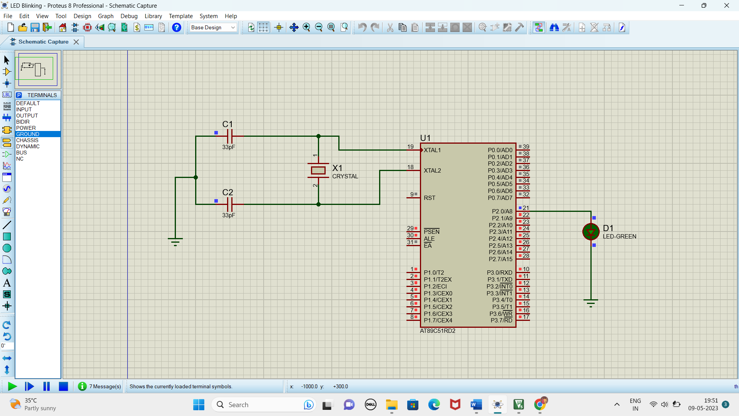

**RESULT**

Thus the program has been successfully verified and executed.